|  |  |
| --- | --- |
| Course: | INFO-3136 Summer 2021 |
| Professor: | Bill Pulling |
| Project: | Pandemic Simulator Application V. 1.1 |
| Due Date: | Saturday, August 7, 2021, by 8:00 p.m. (2000 hours) |
| Service Packs: | Service Pack 1: corrects typo on page 5, which should read 0.3%, not 3%. Correction is in RED FONT. |
| Submitting: | See last page for instructions. |

Note: This project may be done individually *but it is strongly recommended that you do it with a partner or in a group of three or four*! If you do partner up with others, give yourselves a “company name”, and ensure that all names are included in the doc header of each and every class you submit.

The science of epidemiology is defined as “*the branch of medicine which deals with the incidence, distribution, and possible control of diseases and other factors relating to health*” (from the Oxford English dictionary online edition).

The difference between an epidemic and a pandemic is one of geographical scale. An epidemic typically is an outbreak of a disease that is localized to one geographic area. A pandemic consists of multiple outbreaks of the disease spread over several continents. The age of international air travel has made it much easier for a disease to transition from a local epidemic into a worldwide pandemic in a very short time.

As computing technology has advanced over the past fifty years, computer programs designed to model the spread of diseases through a population have become important tools in attempts to control epidemics and pandemics of contagious diseases. Pandemic simulations based on how a disease is transmitted can help medical authorities recommend various counter-measures such as wearing masks, physical distance rules, and whether certain activities in a society (such as attending school classes, or going to restaurants or concerts) should be limited or even stopped completely.

Such simulation software has been used by the government medical authorities in Ontario to advise the government on their response to the current COVID-19 pandemic.

**Your Mission:**

You task is to build a GUI application that will allow the user to input certain parameters about a population in terms of how many people are vaccinated or unvaccinated, and then run a simulation to see how quickly a disease will spread through a population of a given size. The application will simulate a period of three weeks in which there will be one infected person in the population at the start of the simulation. Then, this infected person will interact with the rest of the population and we will be able to see how the disease can spread, based on certain assumptions about the level of protection against the disease in the rest of the population ( i.e. from being vaccinated, or from having already had the disease and thereby acquiring natural immunity).

NOTE: the mathematics behind pandemic simulation software can actually be quite complex, but we are going to be using fairly simple assumptions related to how probable it is that one individual could contract the disease from an infected individual.

ON the next page are some screen shots from an early prototype.

The first screen shot shows the start of the simulation with just one infected person (the red dot) in a population of 600 uninfected (the blue dots) people. As the simulation progresses, the dots will all move about the screen randomly by distances of up to 5 pixels.

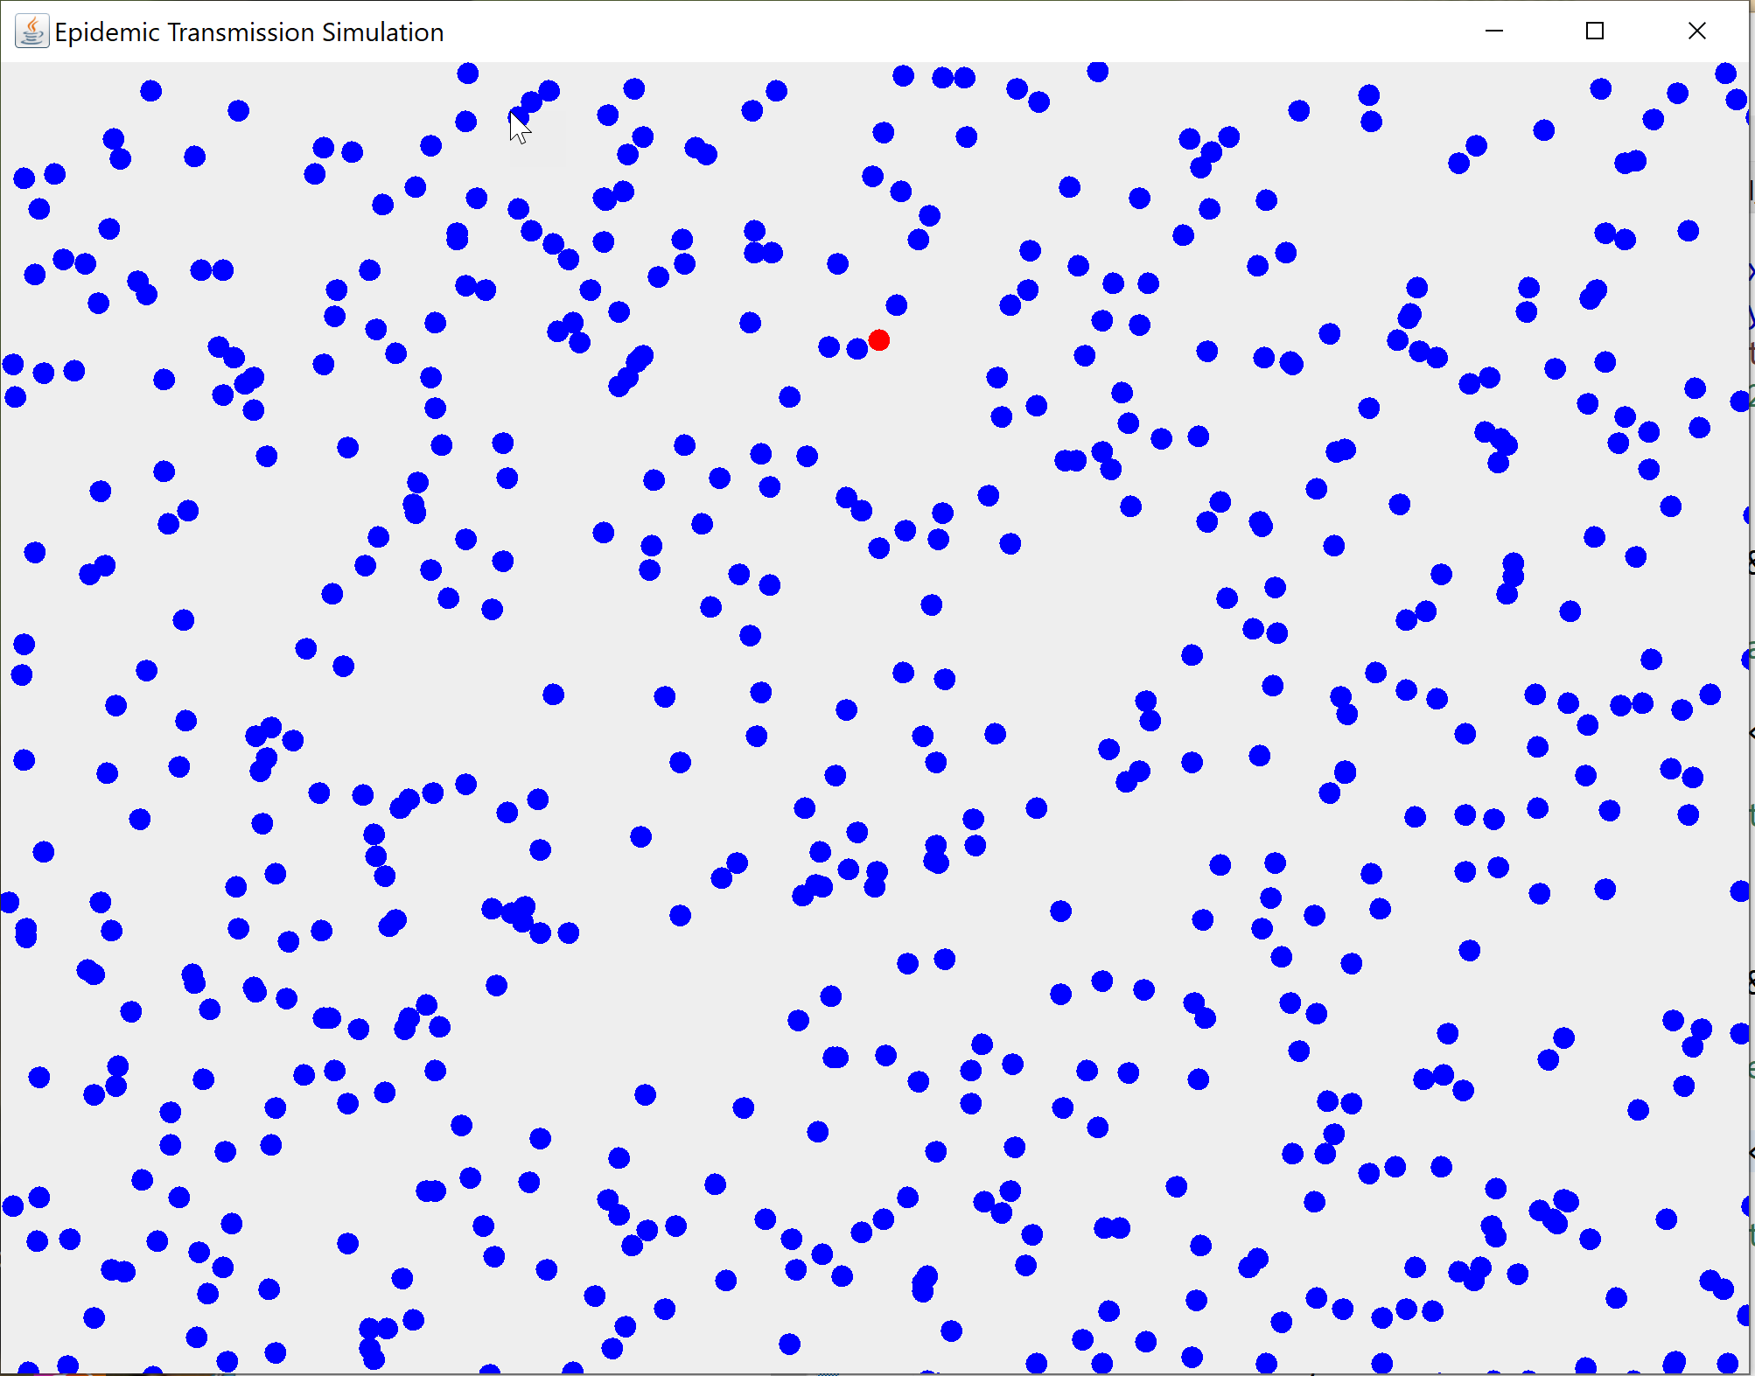

This next screen shot shows the situation after about 150 cycles of the simulation, which is about 30 seconds later, based on a Timer object lag time interval of 200 milliseconds, which means the screen gets redrawn about 5 times per second.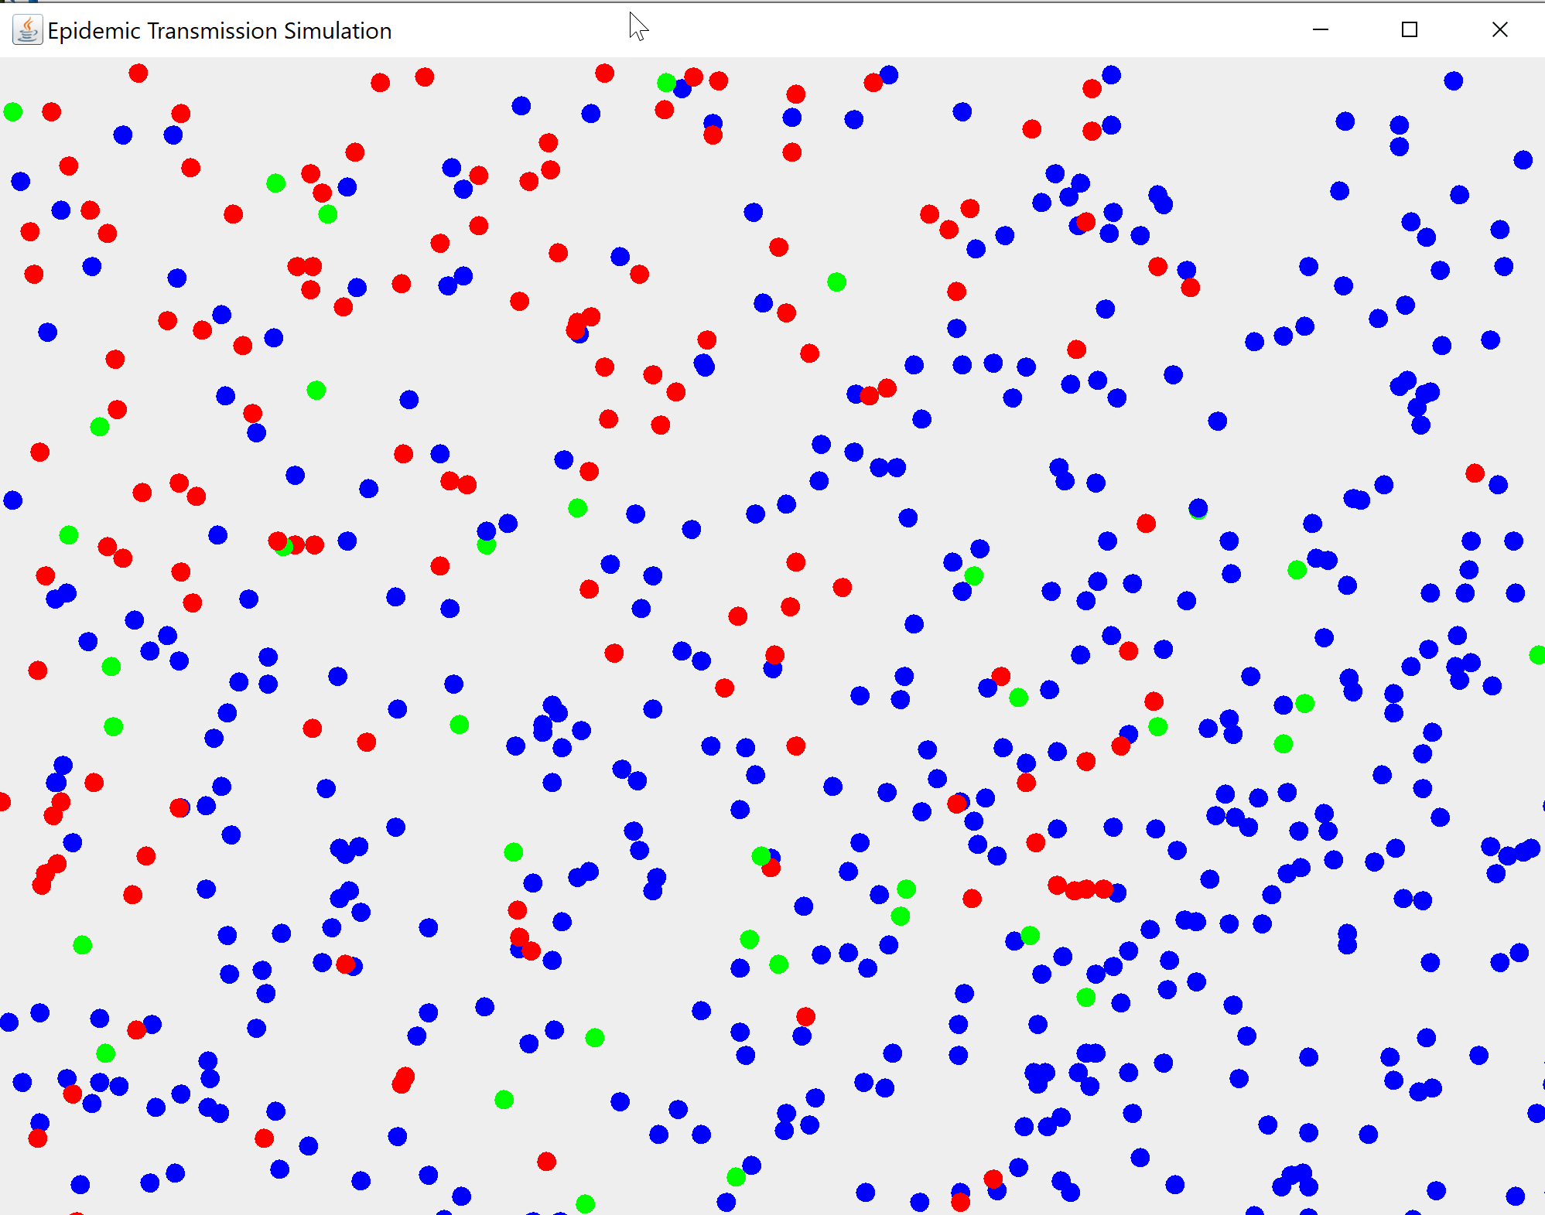

On this screen, the red dots are infected persons. The blue dots are uninfected persons. The green dots are infected persons who have recovered from the disease after about 100 cycles, and are no longer infectious. Not seen on this screen are any black dots, which indicate an infected person has died from the disease.

As the simulation runs, collisions will occur between the moving dots. If an infected dot collides with an uninfected, unvaccinated person, then there is an 80% chance that the uninfected person will become infected and start spreading the disease.

**The Details**

In the simulation, a person infected status can either be true(infected) or false(not infected). On the screen shots a red dot represents an infected person.

A person’s **immunity status** can be in one of several different states, which are mutually exclusive.   
  
1) a person is not vaccinated, and has not had the disease and therefore has no immunity.

2) a person has had one shot of a two dose vaccine and has moderate immunity.

3) a person has had both shots of a two dose vaccine and has strong immunity.

4) a person has had the disease and has recovered, so that they have strong “natural immunity”.

Now, even if a person has had both doses of the vaccine or have acquired natural immunity, they could still contract the disease and become spreaders, although the probability of this happening will be quite low, as will be detailed in the next section.

**Probabilities of Getting Infected**

The probability rules that we’ll use in this simulation for possible transmission from an infected person to an uninfected person are as follows:  
  
1) If an infected person collides with an uninfected person who has no immunity, then there is an 80% chance that the disease will be passed on to the uninfected person.

2) If an infected person collides with an uninfected person who has had ONE shot of the vaccine, then there is a 40% chance that the uninfected person will be passed on to the uninfected person.

3) If an infected person collides with an uninfected person who has had BOTH shots of the vaccine, then there is only a 10% chance that the uninfected person will be passed on to the uninfected person.

4) If an infected person collides with a person who has had the disease and recovered ( a green dot on the screen shot) then there is only a 10% chance that the disease will be passed on to the uninfected person.

5) An infected person has a 10% chance of dying from the disease.

**What You Need to Do to Get Started**:

You need to write a Person class that you can use to create an array of Person objects, which can be drawn as colored dots on the screen. Rather than give you a specific UML diagram for this, I am going to leave the class design up to you, but here are a few hints to help you along the way.

Data members that you might want to include:

**-isAlive (boolean)**: if the object is alive it can move and can be infected. If it is dead, it turns black and stops moving

**-isInfected(boolean)** : set this to true if the object gets infected by another person object.

**-immunityStatus(int)**: an int value that can range from 1 to 4 based on the descriptions noted above. This determines the likelihood of an uninfected object becoming infected if they collide with an infected object. The number of person objects in each immunity state will be determined by an input by the user of the program. For example if the user wants to run a simulation in which nobody has any immunity, then they would enter this into the program before running the simulation and specify that everyone in the population has no immunity. Alternatively, the user may want to specify that 20% of the population has one shot immunity, 40% has 2-shot immunity, 10% has natural immunity, and the remaining 30% has no immunity. You will have to figure out how to create an array of Persons with this distribution. Also, when the user enters the immunity values, you will have to do some data validation to ensure that the percentages add up to 100%.

**-color(Color):** used to determine what color will be used when the object is rendered to the screen. The graphics object g should use this value to draw the object on the screen. You can color-code

your objects using the following scheme.

For infected objects, RED is the obvious color to use.  
For dead objects, BLACK is the color to use.   
For infected objects that have recovered, GREEN can be used to signify their status.  
  
For uninfected objects, you could use different colors to represent different levels of immunity.   
For objects with no immunity, you could use BLUE.   
For objects with one shot immunity, you could use CYAN.  
For objects with two shot immunity, you could use YELLOW

NOTE: one of the things you should add to your visual display is a legend to indicate what each color represents.

**-xCoordinate(int) and yCoordinate(int):** these will hold the position where the object will be drawn on the drawing panel. These are randomly generated when the object is instantiated. You should ensure that the values are within a range so that a person object will not be placed outside of the drawing surface of your JPanel.

**-xIncrementValue(int) and yIncrementValue(int):** these represent the number of pixels that the object will “move” in each drawing cycle. The value of each can range from -5 to +5 pixels. At instantiation time these values should be randomly generated and assigned so that a particular Person object could be drawn anywhere on the drawing surface.. These values will also be modified if the object collides with another object so that the objects will probably change direction after the collision.

**-cycleCounter(int)**. this is used to determine how long an infected object remains infections. It starts at zero and **only starts** **incrementing** when the object’s infected status changes to true. One of the assumptions we’ll use in our model is that an infected person will be infectious for a maximum of 7 days, so we’ll arbitrarily set the end of the infectious stage at a count as 150 cycles. .

NOTE: you are not limited to the data members listed above. If you can think of other data members that you might find useful, you can add them in, but be sure to document WHY and WHAT the new variables will be used to do.

All the data members should be private, and you should provide whatever getters and setters you think are necessary.

**Methods to Consider:**

You will need at least one constructor method, but you can have more if you think you need them.

You will need a **move()** method to calculate the new positions for each object for each drawing cycle.

Also, you will need a **checkCollision()** method to check to see if a collision has occurred between two objects. If it has, you will need some code to determine what state variables should be changed for the objects involved. Two variables that should be changed for both objects involved in a collision are the xIncrementValue and the yIncrementValue so that the dots will have their direction of travel altered randomly.

**You can add any other methods as required** to accomplish whatever functions you need to do, but make sure the methods are COMPLETELY DOCUMENTED so I know what the logic is doing.

**NOTE:** you also need to determine if any infected dots live or die. ONLY AFTER an infected object has stopped being infectious (150 cycles from when it got infected), there is a probablility that the infected dot will die, depending on its immunity status.  
An unvaccinated person has a 10% chance of dying.  
A partially vaccinated person has a 5% chance of dying.  
A totally vaccinated person has a 1% chance of dying.  
A person who had the disease, recovers, andcatches the disease again has a 0.3% chance of dying.

If the person object does die, then its color should be set to black, and its xIncrementValue and yIncrementValues should be set to zero so that it stops moving.

**User Input Parameters**

The user should be able to vary the input parameters listed below:

1. Size of the population: Our drawing area could represent some physical space, such as a college campus, a shopping centre, or a factory or warehouse space. The user might want to run a simulation with just a few hundred persons, or with a few thousand persons in the space to see how the number of persons in the space affects the spread of the disease.
2. Levels of immunity for specified percentages of the population. The user might want to assume that no one is vaccinated, and then run a simulation. Then, they might want assume that 50% of the population has had both shots, and see the effect on the outcome. The user should be able to say “I want 25% with no immunity, 25% with one shot, 25% with two shots, and 25% who have recovered and have natural immunity.
3. We’ll leave it up to you to determine how to get the user input here, but remember Schneiderman’s 8 Golden Rules of User Interface Design. Try to avoid having the user type data into text fields if you can. There are lots of ways to get numeric input without requiring the user to enter it in a text field.
4. PAUSE and RESUME controls: the user may wish to pause the simulation part way through to examine certain data outputs. A simple way to do this is to just call the stop() method of your Timer object. It will stop firing ActionEvents, which should stop the drawing process. When the user wants’ to resume the simulation, they can just call the Timer object’s start() method to resume.

**Duration of the Simulation**

To make the simulation run in a reasonable amount of time, we can make the following assumptions:

1) our lag time between screen repaints should be set to about 200 milliseconds. You can vary this up and down a bit if you feel that you need to, but 200 milliseconds seems to give a good visual display. This will result in the screen being repainted about 5 times per second. So, we will get about 300 repaint cycles in one minute of running time.

2) We would like the simulation to represent a 21 day period. We will arbitrarily say that 150 repaint cycles will represent 7 calendar days, so a complete simulation of 450 cycles would represent a 21 day period. So we will set the number of repaint cycles to be done to around 450. This means so that one run of the simulation will take about 90 seconds and will represent a 21 day period.

**Data Display on the GUI**

The previous screen shots just show the drawing surface and the interactions of the Person objects and did not show any results data.

Before the simulation starts, the following data should be displayed in some sort of “dashboard” or data area on the screen:

1) total number of persons in the population.

2) number of unvaccinated persons in the population, number of partially vaccinated(one-shot) persons, and the number of totally vaccinated (two shot) persons.

After the user presses the START button, we would like to see the following data *updated in real time as it changes:*

1. Number of infected persons.
2. Number of non-vaccinated persons infected.
3. Number of partially-vaccinated people infected.
4. Number of fully-vaccinated people infected.
5. Number of infected people who have recovered.
6. Number of infected people who have died.

**Final Data Presentation**

After the simulation has finished, use the data generated to calculate and display this information:

1. Percentage of the total population that contracted the disease.
2. Percentage of unvaccinated persons who contracted the disease.
3. Percentage of partially-vaccinated persons who contracted the disease.
4. Percentage of fully-vaccinated persons who contracted the disease.
5. Percentage of all those who contracted the disease that recovered.
6. Percentage of all those who contracted the disease that died, broken down by their immunity status. So, for example, if there were 100 unvaccinated persons and 50 got infected, and 5 died, the percentage death rate for unvaccinated persons would be 5/100 or 5%.

**Menu System**

Include a menu system that, at a minimum, allows the user to start and stop the simulation, and also has an “About” menu, which will list the names of each member of the project team.

**Bonus Marks Available**:

There are two bonus marks available. If you are feeling creative, you could also try to present the data in some sort of graphical format. For example, you might show the number of cases per day over the three week period. This is not a functional requirement, but could be done to gain a bonus mark or two.

Another bonus option would be to generate some sort of report listing the inputs and results that could be saved as a text file and sent to a user designated file.

**Submitting your project:**

Since you will likely have several .java source files in this project, you should submit your ENTIRE ECLIPSE PROJECT folder by zipping it up and then submitting it to the drop box. All source files should include a proper documentation header comments listing the names, student numbers, and section numbers of each person in the group.

**Submit your project on time!**

Project submissions must be made on time! Late projects will be subject to the following late policy:

Up to one day (24 hours) late: 10% reduction

A further 10% reduction for each additional day late up to a maximum of 5 days.

After five days late: mark of zero is assigned.

How will my project be marked?

* This project counts for 10% of your final mark and will be graded using to the following grid:

|  |  |  |
| --- | --- | --- |
| **Marks Available** | **What are the marks awarded for?** | **Mark Assigned** |
| 1 | Good coding style including proper indentation and use of variable and class naming conventions and suitable commenting. |  |
|  | **GUI Design and Layout** |  |
| 6 | GUI Design is well laid out and easy to use and navigate.  -minimal use of text fields for data input  -good use of screen space, layout is well balanced -  -has a menu system with basic instructions, and an “About” screen listing the names of all persons on the project team. |  |
|  | **Functionality** |  |
| 13 | User is able to set the various parameters as specified.  data validation is done where necessary.  -simulation runs and produces reasonable results based on inputs.  -simulation results are updated in real time and clearly presented.  - final data display is complete according to specifications |  |
| 20 | TOTAL |  |
| 2 | **Bonus Marks**: will be assigned at instructor’s discretion for outstanding features beyond the basic requirements |  |
|  | GRAND TOTAL |  |